Testing

Trackplan1

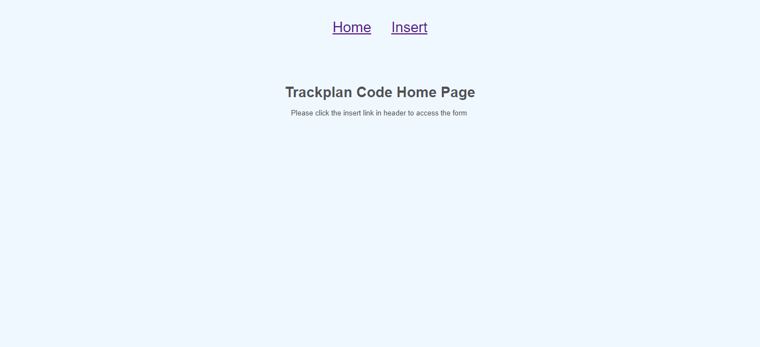

Screenshot 1 is an image of the home page when the application is first loaded. You click the insert link in the header to access the form.

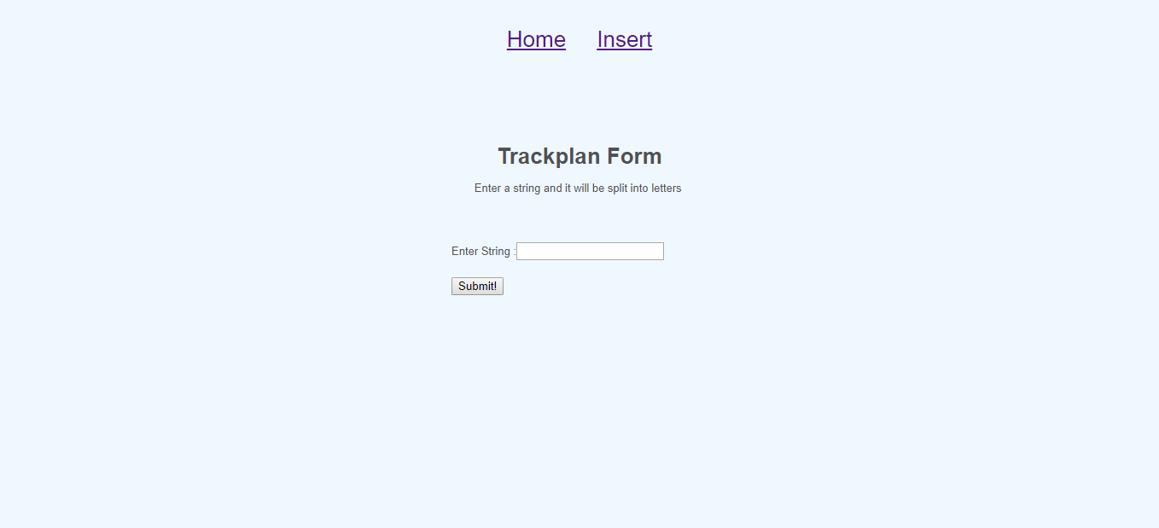

Screenshot 2 is the form before any data is entered.

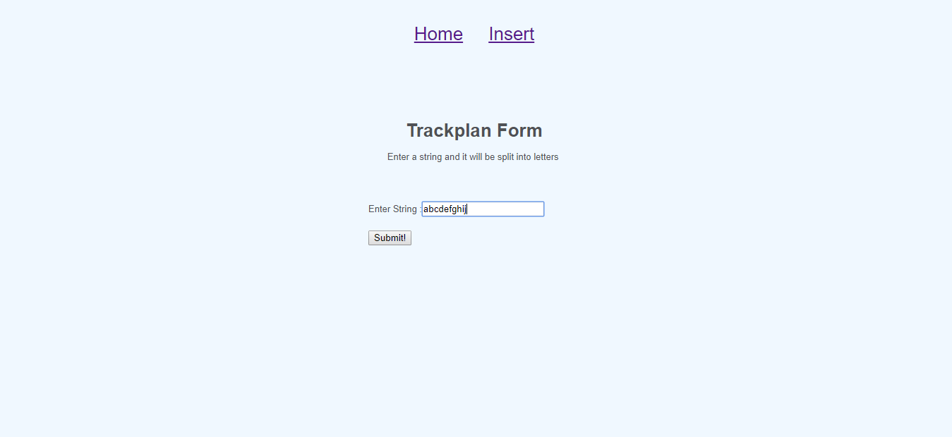

Screenshot 3 is the form again with the letters a to j typed into the textbox. Once the submit button is clicked the display page will load unless the box is empty the an error page will appear.

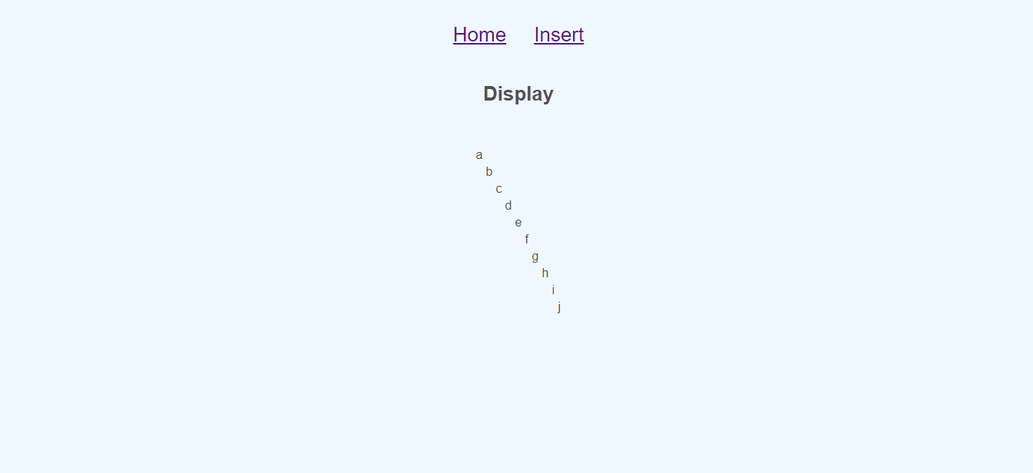

Screenshot 4 is the display page which is displaying the letters in a diagonal line using a table.

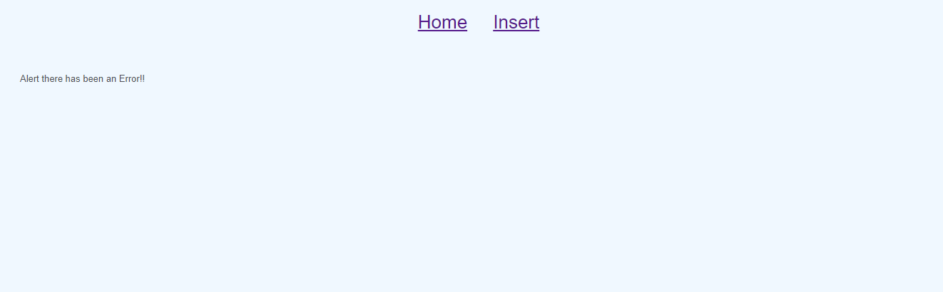

Screenshot 5 is the error page.

Trackplan2

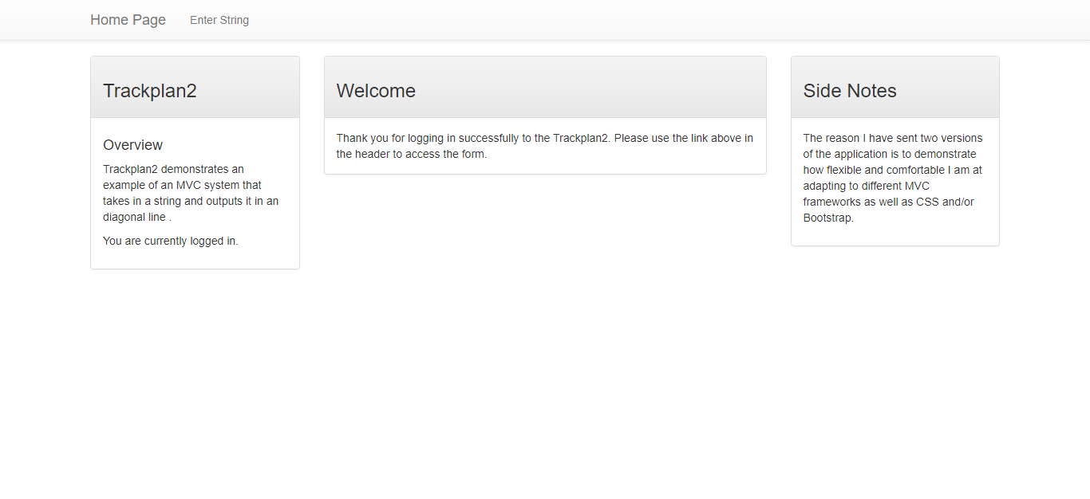

Screenshot 1 is of the home page which is loaded when the application is run. The link in header file must be clicked to access the form and display page.

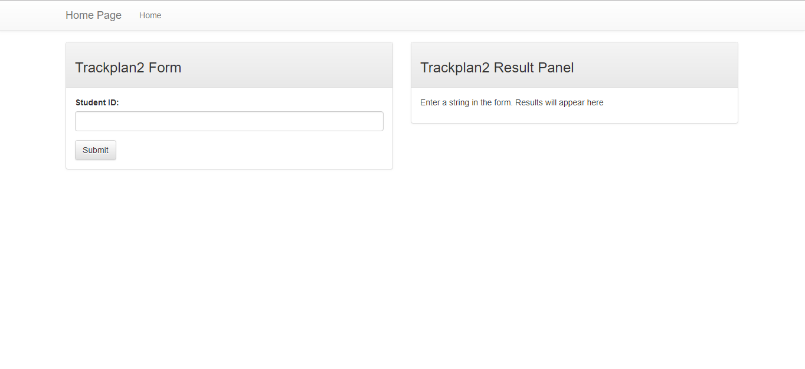

Screenshot 2 is of the display and form page before any data is entered to the form page.

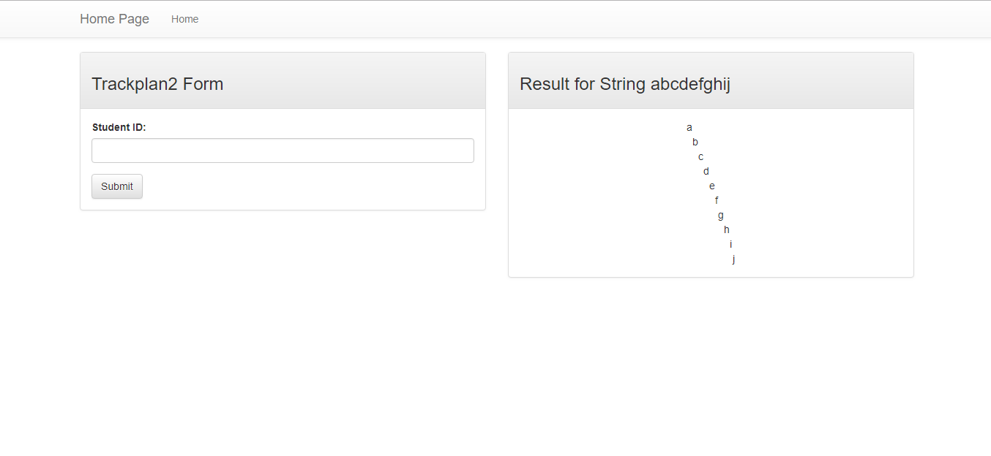

Screenshot 3 is of the form and design page after the letters a to j have been entered and the output is displayed to the right of the same page.